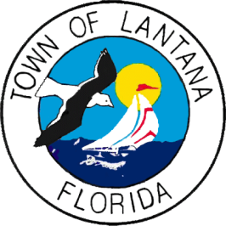
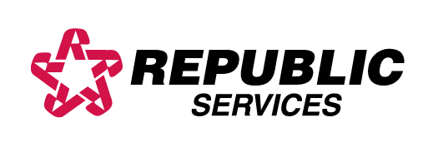
Effective October 1, 2018
Solid Waste and Recycling Information
Customer Service (561) 478-9590
South West of Pine Street

Tuesday = Garbage & Vegetation
Friday = Garbage, Recycling & Trash/bulk
Trash/bulk is serviced only once a week!

North side of W. Pine St./ALL streets West of
14th St. & ALL Hypoluxo Island
Monday = Garbage & Vegetation/yard waste
Thursday = Garbage, Recycling & Trash/bulk
Trash/bulk is serviced only once a week!

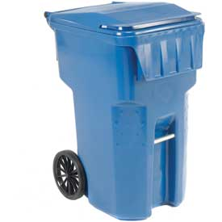

Garbage
- 95-gallon Garbage containers may be set out any time after 6:00 PM on the day before collection day or by 7:00 AM on collection day. Containers should be removed from the curb within 12 hours after collection.
- Construction and demolition are limited to 2 cubic yards.
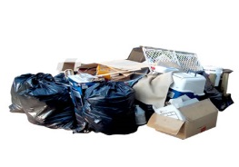
- Republic WILL NOT collect the following items: Tires, motor oil, paint or loose materials
(not packaged or contained properly).

Trash/Bulk Items
- Bulk items such as household furniture, appliances, etc. will be serviced ONCE a week on scheduled bulk day.

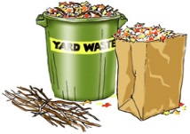
Vegetation/Yard Waste
ITEMS MAY BE PLACED OUT 48 HOURS IN ADVANCE
- All grass clippings, leaves, pine needles, coconuts and similar small loose items MUST be bagged or containerized.
- Vegetative waste, except palm fronds must be no more than 6 feet in length.
- No single item shall weigh more than 50 pounds and shall be placed neatly at the curb.
- Natural Christmas trees will be collected as vegetative waste and must be no more than 8 feet in length and less than 50 pounds.
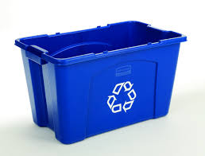
- Tree Trimmers, etc. – Privately employed tree trimmers, tree surgeons, landscape contractors and operators of tree & shrubbery maintenance services shall remove ALL trash and debris from the premises upon which they are working, including but not limited to limbs, tree trunks, roots, shrubbery clippings & other debris emanating from their work [Town of Lantana – Code of Ordinance, Garbage & Refuse Disposal, Article II, Division 1, Sec. 9-16 (i)].
Recycle
- Bins should be placed at the curb for pick up before 7:00 AM on your scheduled service days
but no earlier than 6:00 PM the day prior to collection.
- Recycling bins containing materials other than recyclables will be tagged and not picked up.
- Rechargeable batteries and cell phones can be recycled. These items may be dropped off at Town Hall, Operations Center, Police Department or the Library.
Items that cannot be placed in recycling bins
Food waste
Light Bulbs
Plastic wrap
Plastic bags
Styrofoam
Yard waste

Blue Bin
Drink Boxes
Milk and Juice Cartons
Aluminum and Steel cans
Glass bottles and Jars (all colors)
Plastic containers #1-7

Yellow Bin
Newspapers & Inserts
Brown Paper Bags (Grocery Bags)
Magazines/Catalogs/unwanted mail
School and office paper
Cardboard boxes
Dry food and tissue boxes
Beverage cartons (Boxes must
be flattened or cut to 3’x3’)

The following Holidays are observed: Thanksgiving and Christmas. If your collection day falls on a holiday, collection will resume on your next scheduled service day.

